**IMPLEMENTATION OF DECENTRALIZED BLOCKCHAIN**

**SUPERVISOR HEAD OF THE DEPARTMENT**

**HARIHARAN, M.E, Ph. D DR.S. MURUGAVALLI, M.E. ,Ph.D**

**(PANIMALAR ENGINEERING COLLEGE, CHENNAI-600123)**

**(AUTONOMOUS)**

**JOURNALS SUBMITTED BY,**

**SURYA R [211418104279]**

**SURYA S [211418104280]**

**YOGESH KUMAR K [211418104316]**

## ABSTRACT

Developing a secure central system that not only accelerates the process of land registration but also makes it efficient will be effective. This project presents a blockchain-powered real estate management system that will provide a transparent, secure, and efficient system for real Signature estate management. The proposed project allows a real estate agent to register a new person. It also allows a real estate agent to register a property sale against a registered person. Blockchain technology and smart contracts can sort out the classical issues that RE is facing, and they offer much more meaningful tools for a game-theoretic stable-priced market

***KEYWORDS*** Blockchain

## INTRODUCTION

The advent of blockchain technology has been set to revolutionize the real estate industry, and the potential changes are already taking shape. The real estate industry is one of the top global sectors that is driving the economic growth of any country. The growth of this industry is well complemented by the growth of the corporate environment, demand for office space, industrial plots, urban housing accommodations, agricultural lands, etc. However, the existing world of real estate is complicated by the lack of transparency in its transactions such as leasing, purchasing, and sales, and fails to attain the level of confidentiality and authenticity of operational data. Several aspects of its operations such as property sale prices, sale history, lease rental rates, market valuation, and so on expect greater demand for transparency, data integrity, and security—a trusted environment. As a result, property-related information can be made available as digitized information and hosted as a decentralized database of records on distributed systems with a lesser incidence of fraud and inaccuracies.

## EXISTING SYSTEM

The existing system doesn’t use blockchain and the existing system is mainly owned by agencies and brokers. Also there are many scams and frauds occurring in the existing system due to the security issues.

## PROPOSED SYSTEM

The Proposed system is built in a secured by storing all the data in a blockchain so there won’t be any frauds and scams can possibly happen.In the proposed system, fractional ownership feature is also added so if many users can have a small fraction of ownership in a big land.Also the proposed system will allocate NFT ( non – fungible token ) to all the buyers who are buying , so there avoid online and fake document scams.

## SYSTEM DESCRIPTION

The figure below is merely a summary of all of the entities that have been integrated into the system. It briefly outlines how our proposed system's complete voting process will work, from the administrator initiating a fresh ballot for election through numerous voters casting their votes. It also depicts their interrelationships and includes a series of decision-making procedures and steps. This graphic also explains functional correspondences.

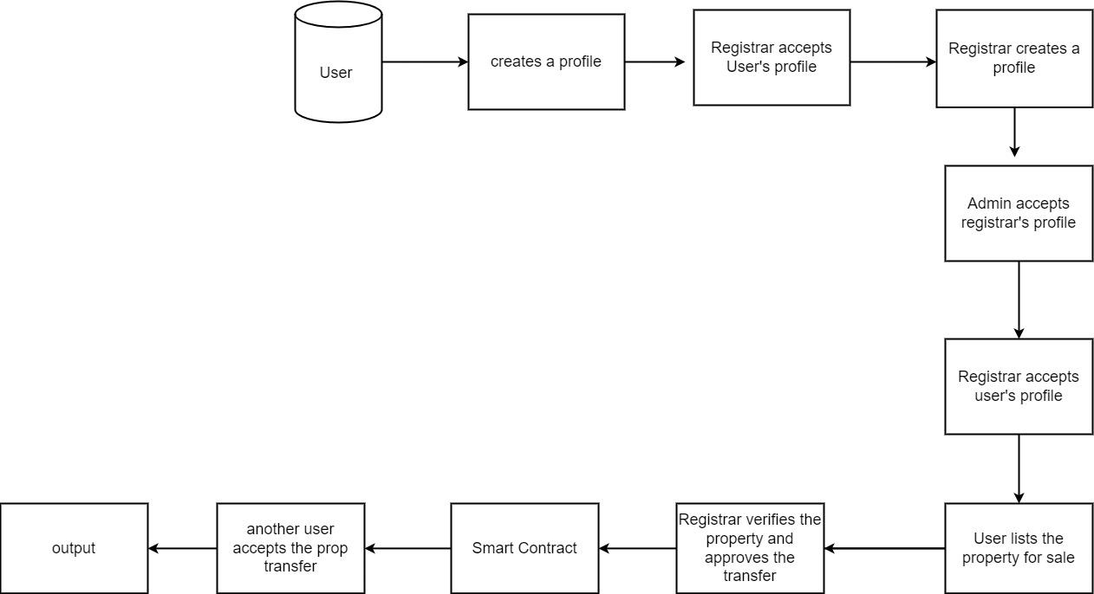

# Fig:1 System Architecture

The modules involved are

* User module
* Admin module
* Registrar module

**USER MODULE**

This is the module in which the user performs their activities.The user has an option to be registrar/user. The user then will put can put up request to register property; mentioning no of property fractions. The structure of an approves user will be like this :

struct ApprovedUser {

uint id;

string name;

uint districtCode;

address pAddress;

uint propertyCount;

uint aadharNumber;

bool acceptanceStatus;

}

**ADMIN MODULE**

The admin has to add the properties. Also the admin will accept all the registrar requests done by the user. The pseudocode of the adding districts is of below: address public admin;

constructor() public {

admin = msg.sender;

}

function addNewDistrict(string memory _districtName, string memory _stateName, uint _districtCode) public onlyAdmin(){

require(isDistrictCode[_districtCode] == false, 'district already taken');

districts[nextDistrictId] = ApprovedDistrict(

nextDistrictId,

_districtName,

_stateName,

_districtCode,

0,

false

);

isDistrictCode[_districtCode] = true;

districtCodeToDistrictId[_districtCode] = nextDistrictId;

nextDistrictId++;

}

**REGISTRAR MODULE**

The users who are registering as registrar will have this registrar dashboard. The users can initiate property transfer request, which should be accepted by receiver and registrar. The pseudocode of the accept transfer is of below:

function acceptTransferRegistrar(uint _propId, uint _partId) public {

Property storage prop = props[_propId];

require(isUnderTransfer[_propId][_partId] == true, 'transfer has not been initiated');

address newOwnerAddress = newOwner[_propId][_partId];

uint registrarId = districtToRegistrar[prop.districtId];

registrarId];

require(msg.sender == registrar.registrarAddress);

require(registrarAccepted[_propId][_partId] == false, 'already signed');

}

**RESULTS**

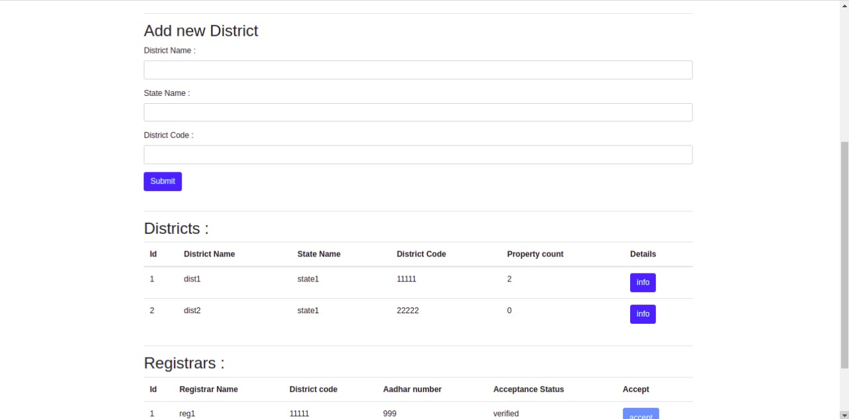

# Fig:2 Add new district page

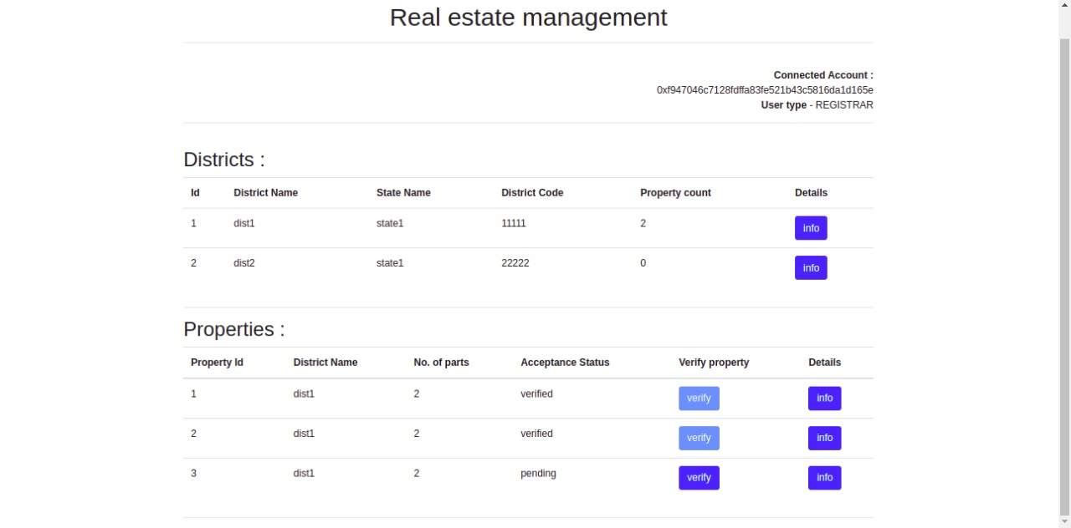

# Fig:3 View Districts and properties

## CONCLUSION

Using Blockchain, we solved the existing issue that causes a lot of fraud online real estate transactions. The most important feature of our system is the fractional ownership so that anybody can buy any part of the land and our security layer is one of the most secured data protection layer that prevents from all type of data attacks. Also since our blockchain architecture is well built considering scalability, the system can be well enhanced in the future with additional features. Since our proposed system is built with VS Code and Node JS, it can be deployed in a clod architecture using either Netlify or digital ocean or Amazon Web services.

## REFERENCES

[1] Sobhan Latifi, Yunpeng Zhang, Liang-Chieh Cheng, et al. "Blockchain-Based Real Estate Market: One Method for Applying Blockchain Technology in Commercial Real Estate Market." [2019 IEEE International Conference on Blockchain (Blockchain)](https://ieeexplore.ieee.org/xpl/conhome/8938397/proceeding).

[2] Ankit Mittal,Bhavyansh Sharma,Pinku Ranjan et al."Real Estate Management System based on Blockchain." 2020 IEEE 7th Uttar Pradesh Section International Conference on Electrical, Electronics and Computer Engineering (UPCON).

[3] Dipika Bhanushali, Akshara Koul, Sainiranjan Sharma,Bushra Shaikh. "BlockChain to Prevent Fraudulent Activities: Buying and Selling Property Using BlockChain." 2020 International Conference on Inventive Computation Technologies (ICICT).

[4] Mirko Avantaggiato, Pierluigi Gallo. "Challenges and Opportunities using MultiChain for Real Estate" 2019 IEEE International Black Sea Conference on Communications and Networking (BlackSeaCom).

[5] K Madhura, R Mahalakshmi. "Usage of block chain in real estate business for transparency and improved security" 2022 International Conference on Advances in Computing, Communication and Applied Informatics (ACCAI)

[6] Ankit Mittal,Bhavyansh Sharma,Pinku Ranjan. "Real Estate Management System based on Blockchain." 2020 IEEE 7th Uttar Pradesh Section International Conference on Electrical, Electronics and Computer Engineering (UPCON)

[7] Aleksandr Belov, Sergey Slastnikov. "Blockchain Technology to Manage the Energy Supply of Real Estate." 2021 IEEE International IOT, Electronics and Mechatronics Conference (IEMTRONICS).

[8] VO Khoa Tan, Thu Nguyen. "The Real Estate Transaction Trace System Model Based on Ethereum Blockchain Platform." 2022 14th International Conference on Computer and Automation Engineering (ICCAE).

[9] Jack Laurie Tilbury, Ed de la Rey, Karl van der Schyff "Business Process Models of Blockchain and South African Real Estate Transactions." 2019 International Conference on Advances in Big Data, Computing and Data Communication Systems (icABCD)

[10] Jun Yan, et al. "Multilateral Game in Chinese Real Estate Price: A Game Analysis of Real Estate Tax and Land Tightening" 2013 Sixth International Conference on Business Intelligence and Financial Engineering (BIFE).